**UCS Configuration Script Instructions**

***Revisions:***

*V1.7 Initial release to the general VCE D&I audience.*

*V1.8 updated error handling, made data file save default, and added decommissioned blades.*

*V1.10 Updated user input method, normalized some variables internally.*

*V1.11 Removed WMI popup, this allows for batch mode.*

**About**

These instructions are for running the UCS Configuration CRG report PowerShell Script. To run this script, PowerShell must be installed on the Windows laptop/server that the script will be run from. The Windows laptop/server must also have connectivity to the UCS system in the Vblock for the default collection of UCS data. The system must have Excel COM object to generate the Compute tab of the Configuration Resource Guide default output.

**Pre-Requisites**

The script requires different pre-requisites based upon the mode being ran. By default data collection and report generation are done at the same time. For this the prerequisites are PowerShell, access to the UCS, proper UCS credentials, and Excel loaded. For generating a data dump, you do not require Excel to be loaded. For generating a report, you do not require credentials or access to the UCS.

**Modes of the Script**

The script has many modes; the default is to execute the PowerShell script without any arguments. This mode connects to UCSM Cluster, grabs data, builds excel object, saves and displays the report, and exits

* Default: N1K-UCS-V1.10.ps1
* Available parameters and arguments

N1k-CRG-V1.10.ps1 <VBID> <UCSM IP address> <username> <password> -noexcel –noWrite -readin –Batch -nossl

Parameters:

* + <VBID>, File prefix to prepend to the saved outputs of data files and excel report.
  + <UCSM IP address or stored filename>, the ip address to access the UCSM Cluster. if –readin is used then this parameter is where the stored data file is entered.
  + <username>, the username to access the UCSM. only available for the batch mode.
  + <password>, the password to access the UCSM. Only available for the batch mode.

Switches:

* + –noexcel, used to not launch the com object. Used to capture data from a host accessible to the Nexus 1000v but does not have excel installed, say a Jumpbox. This collects stores the data for later processing.
  + –noWrite, used to not save the data file.
  + –readin, used to create a CRG offline. This argument will cause the username and password to be ignored.
  + –Batch, used to execute the script with no user input.
  + –nossl, used to connect to the ucsm cluster via http rather than https

**Instructions**

1. For Default behavior,
   1. From a PowerShell CLI, run the script as follows:

**.\** **UCS-CRG-V1.10.ps1**

* 1. Enter IP addresses to reach the UCSM

1. The script will prompt for user input and ask for confirmation. The following will be asked for:
   1. Enter the Vblock ID
   2. ip address or if “-readin” switch is set the filename of the offline dataset.
   3. Confirmation of the username
   4. Confirmation of the password.
2. The script will now collect the data, build the Excel data.

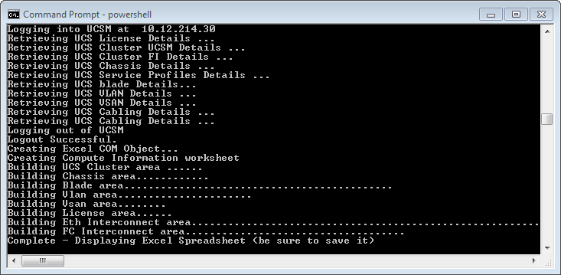

1. Upon completion the script will launch Excel reminding you to save the workbook and exit.

